Lee Stetson
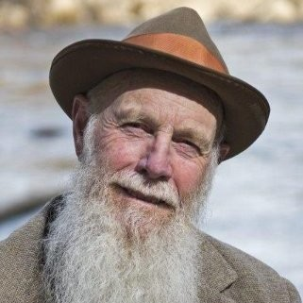
John Muir reprisor, actor/writer, Wild Productions, Yosemite, California
https://www.linkedin.com/in/leestetson
I am an actor/writer. Using my craft to support environmental causes and consciousness is my primary objective, and I hope, may very well bring us together some day. I offer organizations and communities a variety of exciting stage presentations centered on the inspirational writings of the naturalist JOHN MUIR. You may have seen and heard me as Muir's voice in the Ken Burns documentary, "THE NATIONAL PARKS: AMERICA'S BEST IDEA." Muir, known as the father of the National Park idea, founder of the Sierra Club, amazing wilderness adventurer and profound environmental philosopher, is today more deeply relevant than ever. My productions, delivered in Muir’s words, have thrilled and inspired audiences worldwide - at universities, schools at every level, nature centers, parks, museums, libraries, corporations, along with wilderness and environmental organizations from Washington D.C. to Hawaii, from Japan to Scotland. This coming year I'll be performing in Yosemite National Park, on an Alaskan cruise, at the Grand Canyon, in North Dakota, (with Teddy Roosevelt), colleges in New Mexico and California - and with others pending. I tour extensively, and if you thought an engagement in your neighborhood were appropriate, useful, and possible, I'd do all possible on my end to have it happen. My website at www.johnmuirlive.com can provide you with details of the productions, reviews, and contacts. I very much look forward to continuing the dialogue, down trail, Lee

Also from https://www.linkedin.com/in/leestetson
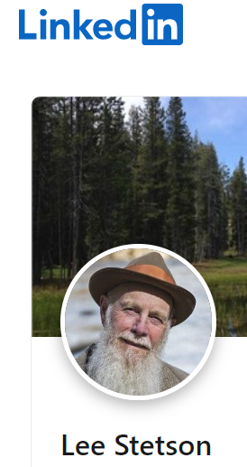
Professional Actor, Writer & John Muir Scholar
John Muir Live
Lee’s portrayal of John Muir has been presented in Yosemite National Park since 1983, to hundreds of thousands of visitors. Additionally, his Muir presentations have toured worldwide to universities, parks, museums, wilderness and environmental organizations from Washington D.C. to Hawaii, from Japan to Scotland.
Lee offers five live performances based on Muir’s life, philosophy and amazing wilderness adventures. He also offers personalized performances and lectures tailored for your event, including A Stroll with John Muir, Customized Shows & Story-telling and Lectures on the Performing Arts & Environment.

From https://yosemite.org/experts/lee-stetson/
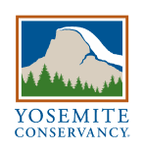
Lee Stetson has portrayed John Muir in Yosemite since 1983 (This is where Sandi & I saw a live performance). Stetson is passionate about promoting the performing arts in national parks. He has performed on stage and television, is the voice of John Muir in Ken Burns’ PBS documentary “The National Parks: America’s Best Idea,” and has been a freelance director.

